FISH 558: Decision Analysis in Natural Resource Management (Fall 2015)
HOMEWORK ASSIGNMENT-4
(Bayesian hierarchical modeling ; Due 6 November 2015)

The purpose of this homework assignment is to use the Markov chain Monte Carlo (MCMC) algorithm to implement a Bayesian hierarchical model and to use the samples from the posterior distribution obtained by applying this model to: a) make a prediction and represent the uncertainty associated with that prediction, and b) construct a posterior predictive distribution for the data for one of the populations.

The data (rows 1-22 on the spreadsheet HWK4Pars.XLS) represent counts of mosquitoes at various distances (sites) along twenty streams. The basic probability model for these data is:
- The counts at each site are Poisson-distributed.
- The expected count at each site is given by:
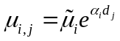 (1)
where 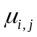is the expected count (Poisson mean) at distance j along stream i,
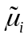 is the expected count at the mouth of the river (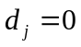),
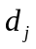 is the distance of the j’th site along each river, and
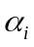 is the rate at which density changes with increasing distance.
- The prior distributions for the parameters are:
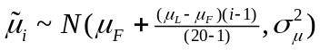 (2a)
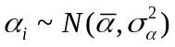 (2b)
where 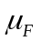 is the expected count at the mouth of the northernmost river (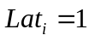), and
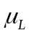 is the expected count at the mouth of the southernmost river (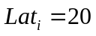).

- Uniform hyper-priors are imposed on , and 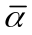 while the hyper-priors on the variance parameters are assumed to be normal with means 1 and 0.01 for 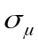 and 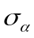 respectively. The standard deviations for the hyper-priors for and are both 0.1.

Tasks:
  - Use the MCMC algorithm (with a multivariate normal jump function) within an R program to generate samples from the posterior distribution. Provide your rationale for the number of MCMC cycles, the burn-in and the thinning rate and also show the posterior distributions for the 45 parameters of the model in the form of histograms. Note that you need to write your own MCMC sampler rather than using one in an R package (i.e. not JAGS or LaplacesDemon).
  - Use the samples from the MCMC algorithm to develop a posterior distribution for the expected count at a distance of 15km along a stream at latitude 12.
  - Use the samples from the MCMC algorithm to develop a posterior predictive distribution for the observations along stream 7 and comment on whether you think the model is adequate.

Note that a document showing the results along with the code should be submitted.
Hints:
    - Start your MCMC chain from the parameter vector listed on row 74 of the spreadsheet HWK4Par.XLS and use the variance-covariance matrix in this sheet as the basis of your analyses.
    - Identify a factor to multiply the variance-covariance matrix by during the burn-in. Look at the examples in lecture 9 for hints how to do this.
    - Use the R function “rmvnorm” in the library “mvtnorm” to generate random variables from a multivariate distribution.

